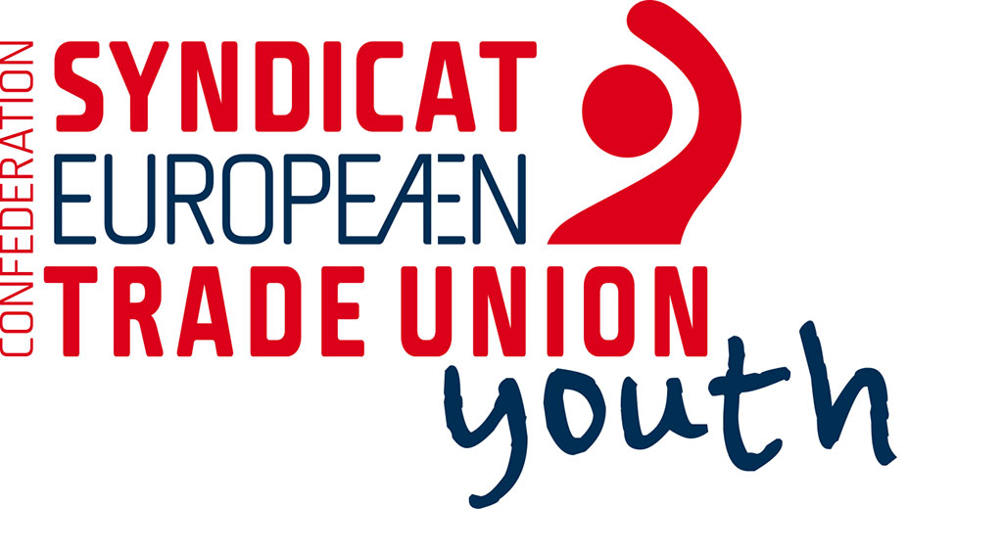

ETUC Youth says: “LGBTQ equal rights, it is time for YES.”

In March 2015 the government of Slovenia adopted changes in the Law on marriage and family relations which would allow same sex couples to get married. With this act same sex couples would also gain all of the rights that heterosexual couples already have. Shortly after the changes of the law were adopted, the civil society who opposed the change, demanded a referendum where the people will decide if the law will come into force.

In the preparations for the referendum, the trade union “Mladi plus” joined a broad coalition of organizations that support the changes of the above mentioned law and together with the Committee for equal rights of the ZSSS publicly supported it and encouraged their members to vote YES.

LGBTQ rights are human rights and these are central to trade union activities. Regardless of race, gender, age, religion, belief, disability, gender identity or sexual orientation, everyone should have the right to dignity and equal treatment without discrimination - in trade unions, in the society as a whole, and certainly at the workplace.

Trade unions should be at the forefront of speaking up for LGBTQ communities, both in the workplace as well as in their other activities. The ETUC Youth committee fully supports the extension of marriage rights to same sex couples all over the world.

The ETUC Youth committee fully supports trade union »Mladi plus” and The association of free trade unions of Slovenia (ZSSS) in their efforts regarding the upcoming referendum about the Law on marriage and family relations. With this declaration the ETUC Youth committee appeals to all of Slovenian workers to attend the referendum on the 20th of December and votes YES – It is time for YES in Slovenia and in Europe.

